Project Goal:
The primary objective is to design and test two variants of a model predictive controller (MPC) for torque vectoring in a two-wheel-drive vehicle during straight-line acceleration under differential traction conditions. A two-track, three-degree-of-freedom vehicle model will be employed. The first MPC variant will utilize a nonlinear Pacejka tire model to accurately capture longitudinal slip, while the second variant will rely on a simplified, linear tire model based on the traction (friction) circle. These simulation scenarios with varying differential traction and vehicle speeds aim to compare the performance of both MPC approaches as well as highlight the limitations of the linear model under more extreme conditions. It is expected that NMPC will yield higher performance when dealing with high-slip scenarios and ensuring optimal traction and stability.
System Dynamics:
The two-track (3 degree of freedom) vehicle model is as shown below.
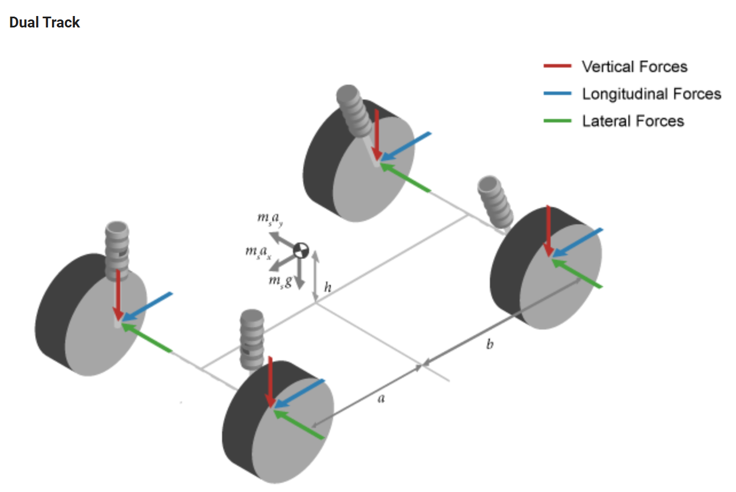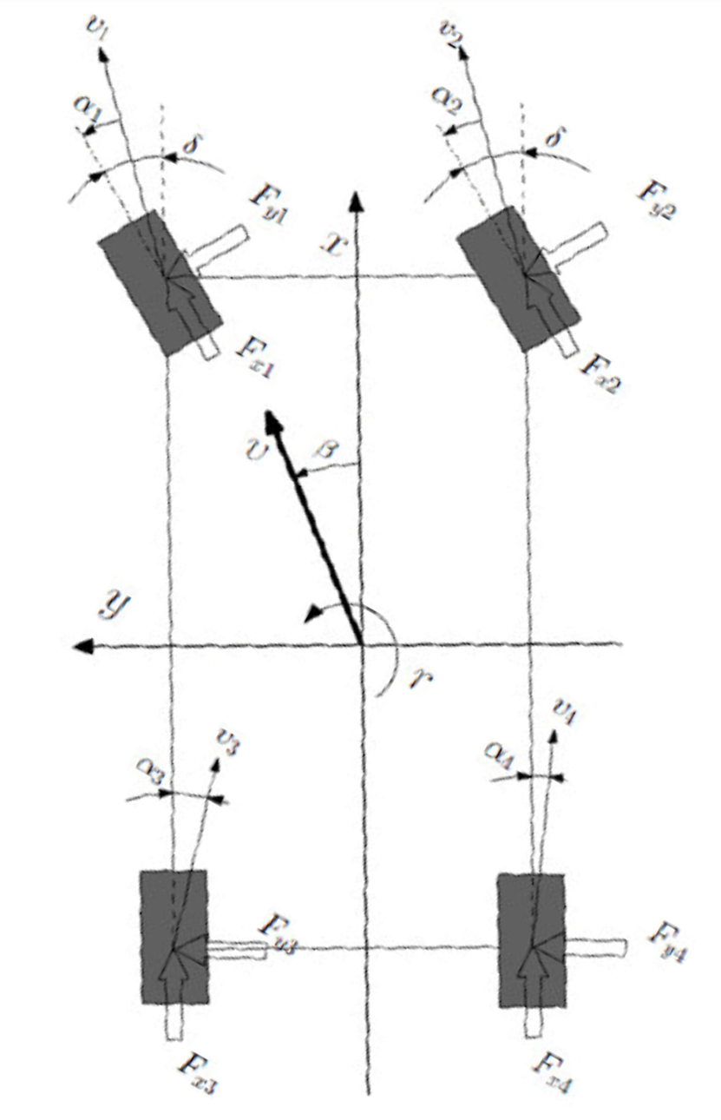
Figure 1: Two track model considers longitudinal and lateral forces at each tire. Longitudinal tractive force is non-linear function of normal force. (source: Mathworks)
Rigid body planar dynamics are given by the below dynamic equations:

$$\ddot{x}=\dot{y}r+\frac{F_{xfl}+F_{xfr}+F_{xrl}+F_{xrr}+F_{drag}}{m}$$
$$\ddot{y} = -\dot{x}r+ \frac{F_{yfl} + F_{yfr} + F_{yrl} + F_{yrr} }{m}$$
$$\dot{r}=\frac{a\left(F_{yfl}+F_{yfr}\right)-b\left(F_{yrl}+F_{yrr}\right)+\frac{t_{f}}{2}\left(F_{xfl}-F_{xfr}\right)+\frac{t_{r}}{2}\left(F_{xrl}-F_{xrr}\right)}{I_{zz}}$$
$$r=\dot{ψ}$$

Where:
$$\ddot{x} → Vehicle frame longitudinal acceleration$$
$$\ddot{y} → Vehicle frame lateral acceleration$$
$$\dot{x} → Vehicle frame longitudinal velocity$$
$$\dot{y} → Vehicle frame lateral velocity$$
$$r → Vehicle yaw rate \left(r = \dot{ψ}\right)$$
$$ψ → Vehicle yaw angle \left(heading\right)$$
$$m → Vehicle mass$$
$$I_{zz} → Yaw moment of inertia about vertical axis$$
$$a → Distance from CG to front axle$$
$$b → Distance from CG to rear axle$$
$$t_{f}→ Front track width \left(distance between left and right front tires\right)$$
$$t_{r}→ Rear track width \left(distance between left and right rear tires\right)$$
$$F_{xfl}, F_{xfr}, F_{xrl}, F_{xrr} → Longitudinal tire forces at front-left, front-right, rear-left, and rear-right wheels$$
$$F_{yfl}, F_{yfr}, F_{yrl}, F_{yrr} → Lateral tire forces at front-left, front-right, rear-left, and rear-right wheels$$
$$F_{x}ext,F_{y}ext→External longitudinal and lateral forces$$
$\left(aerodynamic drag, side wind, etc.\right)$
$$M_{zext} → External yaw moment$$
Lateral tire force is assumed linear with normal force at each wheel, where longitudinal tire forces $F_{xfl}, F_{xfr}, F_{xrl}, F_{xrr}$ are determined as functions of tire slip given by Pacejka’s Formula PF():
$$μ_{fl}\left(s_{fl}\right)=PF\left(s_{fl}\right)=Dsin\left(C\tan^{-1}\left(Bs_{fl}\right)\right)$$
$$μ_{fr}\left(s_{fr}\right)=PF\left(s_{fr}\right)=Dsin\left(C\tan^{-1}\left(Bs_{fr}\right)\right)$$

$$μ_{rl}\left(s_{rl}\right)=PF\left(s_{rl}\right)=Dsin\left(C\tan^{-1}\left(Bs_{rl}\right)\right)$$
The left and right wheel are independently torque controlled. Left and right wheel drivetrains are idealized with the following parameters.
$$I_{left}\text{ - Total inertia of left wheel drivetrain, wheel, and tire as seen by the driving motor}$$
$$I_{right}\text{ - Total inertia of right wheel drivetrain, wheel, and tire as seen by the driving motor}$$
$$B_{left}\text{ - Total damping of left wheel drivetrain, wheel, and tire as seen by the driving motor}$$
$$B_{right}\text{ - Total damping of right wheel drivetrain, wheel, and tire as seen by the driving motor}$$

Dynamics follow:
$$I_{left}\dot{ω_{left}}=T_{motor,left}-B_{left} ω_{left}-T_{load,left}$$
$$I_{right}\dot{ω_{right}}=T_{motor,right}-B_{right} ω_{right}-T_{load,right}$$
Where:
$$T_{load,left}=r_{wheel}F_{rl}$$
$$T_{load,right}=r_{wheel}F_{rr}$$
Objective Function
$$J=w1*\left({\left(T_{left}-T_{right}\right)}^{2}\right)+w2*\left({y_{error}}^{2}\right)$$
Penalizes control effort and error from straight line path, weighted by w1 and w2.
Assumptions and Constraints
Since front tires are not driven, longitudinal slip is assumed zero. Lateral slip is linear with lateral tire force. Since straight line acceleration is only considered, lateral slip may also assumed to be zero. In this case only longitudinal slip of the rear tires would be considered.
Motor follows linear torque curve with:
$$K\text{ - torque constant}$$
Constrained by:
$$T_{max}\text{ - maximum motor torque}$$
$$P_{max}\text{ - maximum motor power}$$
Load transfer should not exceed 85% to any set of two outside wheels, as this risks rolling the vehicle. Acceleration and Jerk should have a soft limit for passenger comfort (source: Science

Direct), and vehicle speed may not exceed 65mph. Longitudinal slip should be constrained (e.g., <~20% is safety limit for ABS) to prevent spinouts or wheel locking. Max tire force at each corner constrained by:
$$\sqrt{F_{x}^{2}+F_{y}^{2}}≤μF_{z}$$
Steering angle may not exceed 30degrees, and steering slip may not exceed 10degrees.
Works Cited
"Automated Vehicle Passenger Comfort: Acceleration and Jerk." ScienceDirect, https://vtechworks.lib.vt.edu/server/api/core/bitstreams/fe6d4ca1-514b-4e2b-b1ac-6561824a9de1/content.
"Construction of a Rational Tire Model for High Fidelity Vehicle Dynamics Simulation Under Extreme Driving and Environmental Conditions." ResearchGate, https://www.researchgate.net/publication/267494023_Construction_of_a_Rational_Tire_Model_for_High_Fidelity_Vehicle_Dynamics_Simulation_Under_Extreme_Driving_and_Environmental_Conditions.
"Other Related Vehicle Dynamics Research." Taylor & Francis Online, https://www.tandfonline.com/doi/epdf/10.1080/00423114.2022.2054352?needAccess=true.
"Rear Wheel Torque Vectoring." Cranfield University DSpace, https://dspace.lib.cranfield.ac.uk/server/api/core/bitstreams/e365eaff-f3c9-4e59-82af-48dc0accd441/content.
"Vehicle Body 3DOF." MathWorks, https://www.mathworks.com/help/vdynblks/ref/vehiclebody3dof.html

$$Type equation here.$$

